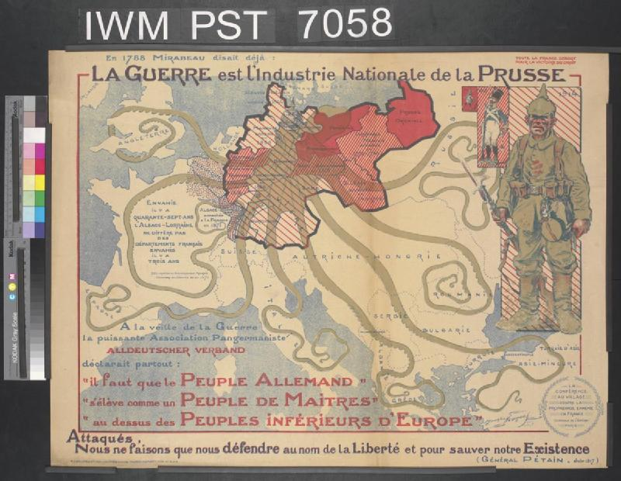

**La Guerre est l'Industrie Nationale de la Prusse (War is Prussia’s National Industry), 1917**

This map is an example of French anti-German propaganda. It suggests that German militarism and her expansionist policies between 1715 and 1914 were responsible for bringing Europe into war. The poster includes a quote from French General Pétain, 'Under attack, we are merely defending ourselves in the name of Liberty and to preserve our lives', to reinforce its claim that France was the victim of German aggression.

"The Road to 1914." *Imperial War Museums*. Imperial War Museums, n.d. Web. 20 Oct. 2013. <http://www.iwm.org.uk/history/the-road-to-1914>.